An Accessibility Analysis of Real-World Websites
Problem Statement: Technology is intended to be inclusive, yet many websites unintentionally exclude people with disabilities. These accessibility barriers are often invisible to designers and developers but create significant challenges for users who rely on screen readers, keyboard navigation, or who have low vision. This project analyzes real-world web accessibility violations to identify systemic patterns of exclusion in digital systems. Using the AccessGuru dataset, we examine:
- Where accessibility failures occur most frequently
- Which types of violations dominate, and
- Which pages create the greatest barriers for users.
Solution Statement: This analysis prioritizes quality over complexity, combining simple analytical techniques with clear insights, actionable outcomes, and a focus on real human impact. Rather than building complex models, we emphasize interpretability, severity-based prioritization, and practical recommendations that organizations can act on immediately.
Dataset
- 3,524 accessibility violations records
- Approximately 590 unique web pages
- 6 Domains Covered: News & Media, Government, Health, Education, Technology, E-commerce
- Violations are aligned with WCAG 2.1 standards and include both frequency and severity indicators.
Data Preparation
- Standardized domain category labels
- Removed unsuccessfully scraped pages
- Aggregated violations at page and domain levels
- Verified consistency between severity scores and impact labels
Assumptions: The dataset reflects reported violations only, so findings should be interpreted as patterns in observed accessibility failures.
Key Columns:
- domain_category: Type of website
- violation_name: What went wrong
- violation_category: Syntactic, Semantic, or Layout
- violation_score & violation_impact: How severe the issue is
- web_URL_id: Unique page identifier
Key Findings
- Which Domains Have the Highest Accessibility Violations?
Accessibility Failures Are Unevenly Distributed. News & Media websites exhibit the highest concentration of accessibility violations, followed by Government and Technology domains or sites.
This suggests that:
- Content-heavy sites introduce more accessibility risks
- Speed and volume of publishing may reduce accessibility checks

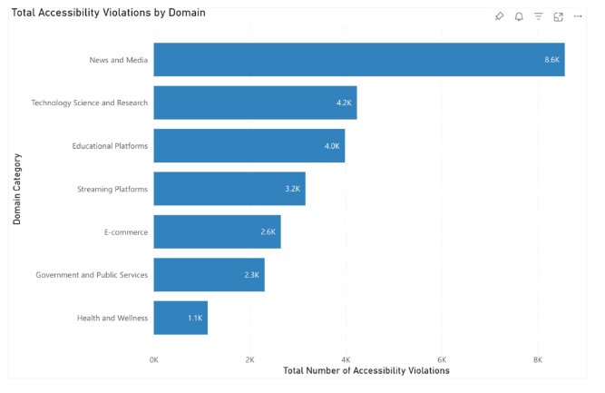
Fig1: Violations by Domain
Implications: This graph indicates that accessibility risk increases with content volume and publishing speed, making accessibility governance especially critical for these domains.
2. What Violation Types Are Most Common?
The top accessibility violations across all domains were:
- Color contrast issues
- Missing or incorrect landmarks (region)
- Missing link names
- Duplicate HTML IDs
- Heading structure problems
These violations appear repeatedly across different industries.
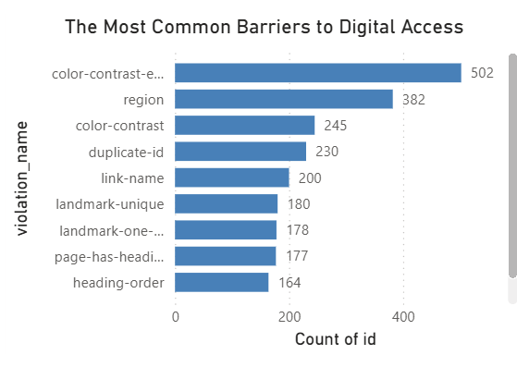
Fig 2: Top Violations
Implications: The recurrence of these violations suggests that accessibility failures are driven more by design habits and workflow gaps than by technical complexity.
3. Are There Patterns by Violation Category?
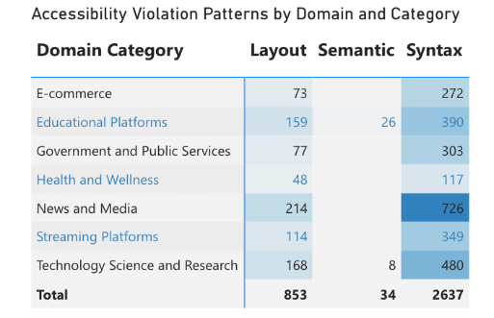
Figure 3: Heatmap- Domain × Violation Category
Observed patterns
- Syntactic violations dominate across all domains
- Semantic violations are rarer but concentrated in Education and Technology
- Layout issues appear consistently but at lower volume
Interpretation
Most barriers arise from incorrect HTML structure and markup. Semantic violations, while fewer, disproportionately affect screen-reader users.
Severity Matters More Than Volume
Not all violations are equal. Some pages had fewer violations but more critical ones, making them much more challenging. To capture this, we introduced a severity-weighted Risk Score to identify pages that cause the greatest harm to users. A simple number that shows how harmful a page is, not just how many mistakes it has.
Risk Score Methodology
Risk Score is calculated as:
- 5 × Critical
- 4 × Serious
- 3 × Moderate
- 2 × Minor
Why does this matter?
- It highlights pages that cause real user challenges
- It helps organizations prioritize fixes
- It turns raw data into an actionable ranking
Unlike raw violation counts, the Risk Score reflects user challenges in accessing the site, allowing organizations to focus remediation efforts where they will have the greatest accessibility impact.
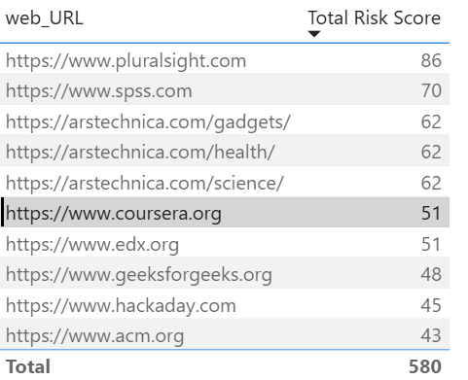
Fig 4: Risk Score Ranking
Using the Risk Score, we ranked pages by accessibility harm.
Risk Score insights: Analysis of the highest-risk pages revealed that:
- A small number of pages account for a large share of critical issues
- These pages often combine:
- Poor color contrast and
- Missing landmarks
- Broken page structure
The Hidden Patterns-Clustering: To identify recurring accessibility failure patterns beyond individual violations, we clustered web pages based on the types and frequency of violations they contained. We applied KMeans clustering (k = 5) on page-level violation profiles. The selected value of k balances interpretability with separation quality, achieving a silhouette score of 0.334, which indicates moderate but meaningful cluster structure in real-world accessibility data.
Method
- Per-domain representation: pivoted counts of violation types per web_URL_id
- Scaling: Standard Scaler to prevent large counts dominating similarity
- Clustering: K-Means (k = 5)
- Risk score: \text{risk} = \text{total\_violations} + 2 \times \text{critical\_count}
- Quality metric: silhouette score = 0.334 (moderate separation)
Summary:
# Pages in cluster | Avg violations per page | Avg critical violations per page | Domains | Risk score | Risk rank
4 | 225.0 | 0.0 | 1 | 225.0 | 1
0 | 147.7 | 3.2 | 50 | 154.0 | 2
3 | 52.1 | 0.4 | 7 | 53.0 | 3
1 | 33.9 | 0.6 | 532 | 35.1 | 4
2 | 3.0 | 0.0 | 1 | 3.0 | 5
Five clusters emerged. Four clusters represent distinct, recurring accessibility problem families, while one cluster contains low-violation or mixed-pattern outlier pages and is not discussed further.
- Contrast-Heavy Pages
- Dominated by color contrast violations
- Particularly harmful for users with low vision
- Navigation Confusion Pages
- Missing landmarks and regions
- Screen reader users struggle to orient and navigate
- Structure-Broken Pages
- Duplicate IDs and broken HTML
- Assistive technologies fail to interpret content correctly
- Heading Disorder Pages
- Incorrect heading order
- Users cannot skim or understand content structure
Implication: This shows that accessibility problems are systematic, not random. These problem clusters enable teams to identify recurring accessibility failure patterns and apply targeted, repeatable fixes rather than addressing violations individually.
Human Impact: Accessibility failures disproportionately affect real people:
Violation Type | Who It Harms | Why
Color contrast | Low-vision users | Text becomes unreadable
Missing link names | Screen reader users | Links make no sense
Missing landmarks | Blind users | Page navigation breaks
Duplicate IDs | Assistive tech users | Page structure collapses

These issues create invisible but significant barriers to access.
Recommendations: Top fixes with highest impact
- Fix color contrast: Violations covered: 747, ~ 21.2% of all violations
- Enforce WCAG contrast ratios through automated design
- Integrate automated contrast testing into design and CI pipelines
- Add semantic landmarks: Violations covered: 869, ~24.7% of all violations
- Use <nav>, <main>, <footer> consistently
- Help improve screen reader navigation
- Ensure meaningful link text: Violations covered: 423, ~12.0% of all violations
- Avoid vague links like “click here”
- Clearly describe the user action and destination
- Include alt text for images used as links
- Validate HTML structure: Violations covered: 763, ~21.7% of all violations
- Ensure unique IDs
- Maintain proper heading hierarchy
These fixes are low-cost, high-impact, and prevent accessibility issues before deployment. Addressing just these four design practices could prevent nearly 80% of all accessibility violations (2,802 out of 3,524) in our dataset.
Conclusion
Accessibility violations are not rare and random. They follow clear patterns, affect specific groups, and can be measured and fixed. By combining data-driven analysis, severity based ranking and human centered interpretation, this project demonstrates how organizations can move toward more inclusive digital systems. Accessibility is not a niche compliance issue, it is a measurable design responsibility, and this analysis shows exactly where to begin.

Reproducibility:
All analysis was performed using Python (pandas, visualization libraries) and validated using Power BI. The approach is transparent, reproducible, and designed for reuse.
Code repository: https://github.com/SunayanaHaz/Data4lyf.git
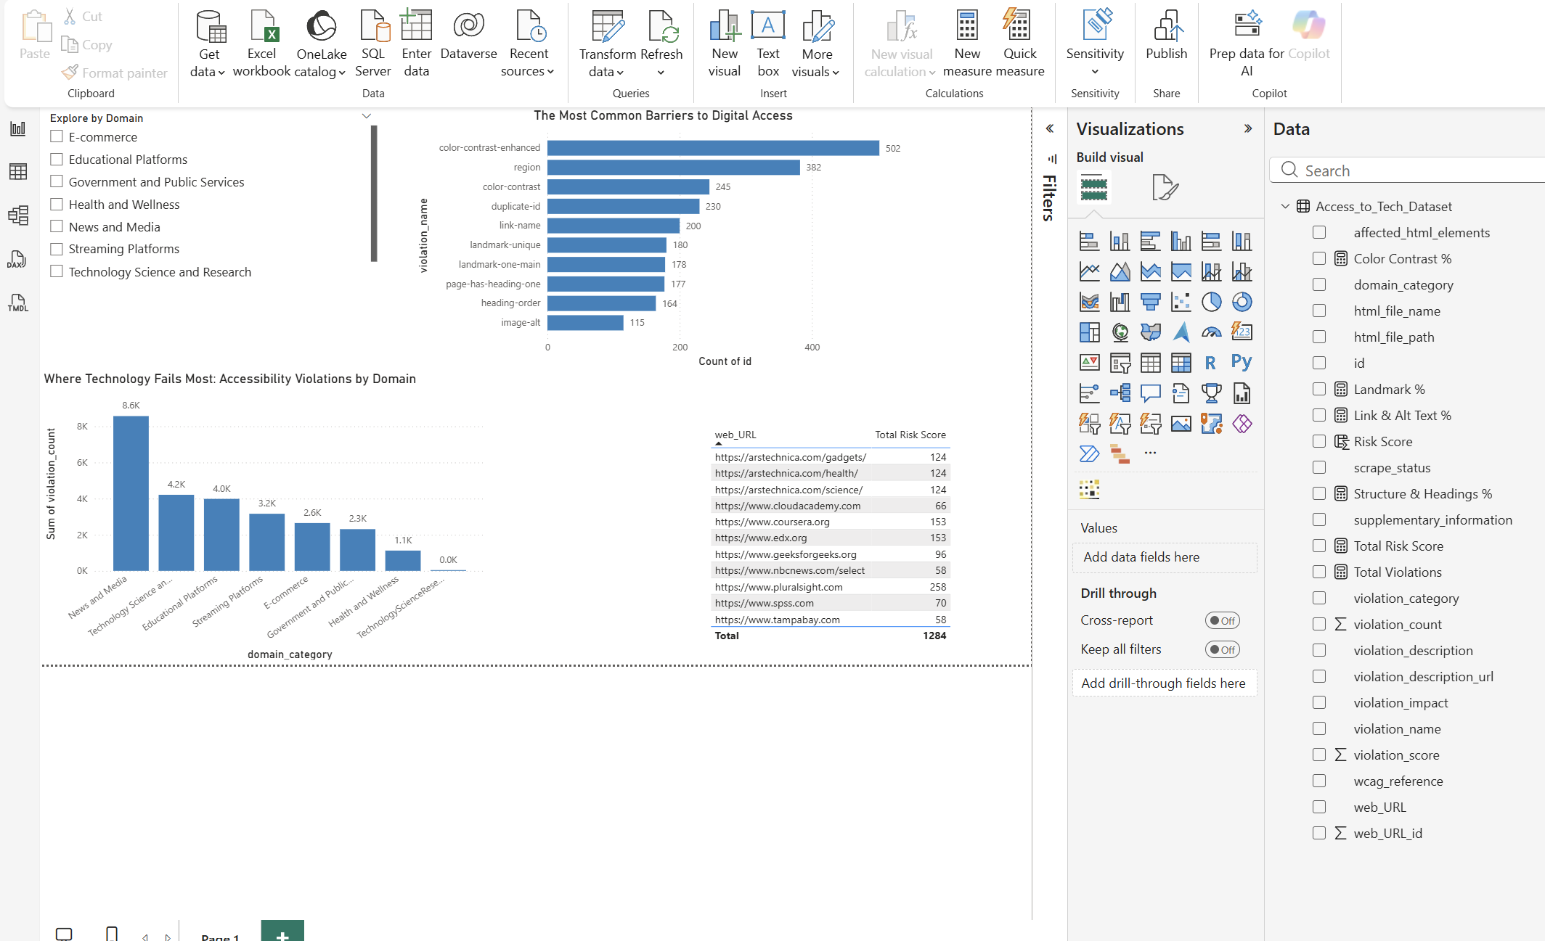
Power BI Dashboard

